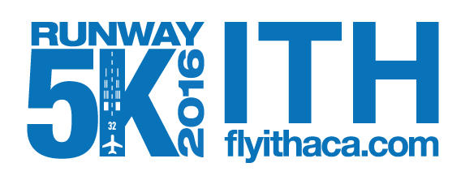
AIRPORT DAY, SEPTEMBER 17, 2017
Website: http://flyithaca.com/
Registration: https://runsignup.com/Race/NY/Ithaca/IthacaTompkinsRegionalAirportRunway5k
Location: Ithaca Tompkins Regional Airport
Course: Loop the Runway and Taxiway, flat and fast
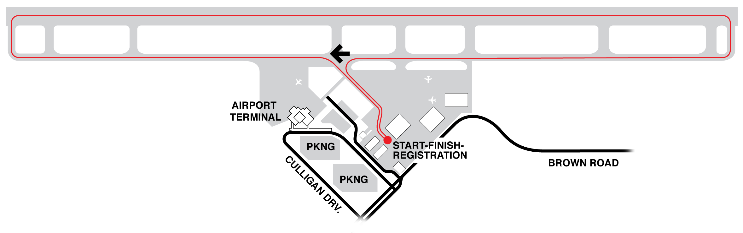
Directions: From West: Follow Route 13 North to the light at Warren Road (just past the Triphammer Road/Pyramid Mall exit). Turn left on to Warren Road. Turn right at the next light on to Brown Road and follow the signs. The airport terminal and parking will be on your left.
From East: Follow Route 13 South from Dryden to the light at Warren Road (just after the highway becomes a four lane road). Turn right on to Warren Road. Turn right at the next light on to Brown Road and follow the signs. The airport terminal and parking will be on your left.
Time: 9:00 AM (depending on airline schedule) Runners will have only one hour to complete the course due to reopening the airport, firm.
Entry Fee: Preregistration $20.00 and includes T-Shirt and ticket to the All You Can Eat Pancake Breakfast at East Hill Flying Club (To receive a shirt registration must be in by September 1, 2017.)
Register online at https://runsignup.com/Race/NY/Ithaca/IthacaTompkinsRegionalAirportRunway5k The race is limited to 515 entries. Packet pick-up is race day from 7:00 to 8:30.
Race Day registrations are $25 and includes a ticket to the All You Can Eat Pancake Breakfast at East Hill Flying Club (no T-Shirt included with same day entry) , from 7:30 to 8:15 AM
Preregistration is highly encouraged at: https://runsignup.com/Race/NY/Ithaca/IthacaTompkinsRegionalAirportRunway5k
Awards: First Male & Female overall will receive a $250.00 travel voucher (rebate with proof of travel) toward airfare from Ithaca Tompkins Regional Airport.
Age groups are 1-14, 15-19, 20-29, 30-39, 40-49, 50-59, 60-69, &70+.
There will be Free parking in the Airport Terminal’s short-term parking lot.
All proceeds benefit the Tompkins County SPCA
ChronoTrack Timing for race provided by Leone Timing (www.leonetiming.com)

